TEMPLATE FOR SUBMISSION OF FULL PAPER
Prepare your full paper in English only using this template and submit at www.iscar.org.in/publications. Kindly register and log in using the generated user ID and Password. Do not forget to check in your interests as author and reviewer in your profile details. Please make sure you have read the full paper submission guidelines and author guidelines prior to submitting your full paper.

Short title: It is to be given at the top of the first page of the manuscript and should not exceed 40 characters [Times New Roman (TNR) in 12 pt Sentence case]. The short title should indicate the topic in a most concise form.

Title of Your Full Paper (TNR Bold 14 pt Centered)

The manuscripts are blind peer reviewed. Therefore, do not add author names with affiliation in the manuscript word file. Authors names should be added in the metadata one by one along with their complete address giving name of the Department, name of Institution, City with zip/postal code, state and country during the process of online submission. Email ids of all the authors should also be entered during submission. Line numbering should be given as indicated here.

ABSTRACT (headlines: TNR Bold 12 pt single space)
The Abstract should be concise not exceeding 300 words and provide a comprehensive summary of the article content. It should not only indicate the subject and scope of the paper but also summarize the findings. It should succinctly summarize the purpose of the paper, the methods used, the major results, and conclusions. Short note will not have an abstract.

Key Words: Key word1, Keyword 2, Keyword 3 (Minimum three and maximum five words in alphabetic order)

INTRODUCTION (headlines: TNR Bold, 14 pt)
Please make the page settings of your word processor to A4 format (21 x 29.7 cm or 8 x 11 inches); with the margins: bottom 2.0 cm (0.78 in) and top 2.0 cm (0.78 in), right/left margins must be 2.5 cm (0.98 in).
The full paper should be prepared in MS Word format (.doc or .docx file). Use double spaced text in 12 point Times New Roman. Please indent the text paragraphs. The introduction must contain background information or brief review work on the research problem, existing knowledge gaps, objectives and hypothesis of the study.
Authors are requested to submit the full paper (not more than 20 pages for full length and 5 pages for short note) in electronic form (MS-Word) via the online editorial system.

MATERIALS AND METHODS (headlines: TNR Bold, 14 pt)

The methodology must be clearly stated and described in sufficient detail and with relevant references.

RESULTS AND DISCUSSION (headlines: TNR Bold, 14 pt)
The findings and arguments of the work should be explicitly described and illustrated. Results should be explained and how the results are similar or different from the published findings should be discussed with support from existing literature. Supporting figures and tables should be presented. The tables and figures should be centered and formatted as shown below. They should be numbered and figure caption/title should be placed under the figure and the table caption/title should be placed at the top. References (if any) of the table and figure should be presented right under the table and figure in the form of author surname and publication date (eg. Dutta, 2019).
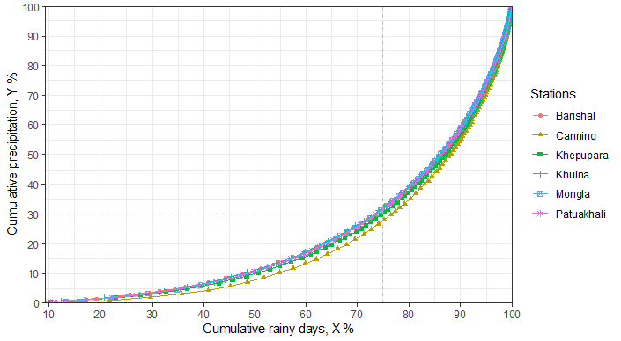

Fig. 2. Concentration curves of cumulative rainfall in the coastal zones (TNR, 10 pt)

Table 3. Observatories in coastal zone in Bangladesh and West Bengal (TNR, 10 pt)

Observatories | Canning | Khulna | Mongla | Barishal | Patuakhali | Khepupara
Latitude (N) | 22º18' | 22º47’ | 22º28’ | 22º43’ | 22º20’ | 21º50’
Longitude (E) | 88º40' | 89º34’ | 89º36’ | 90º22’ | 90º20’ | 90º41’
Elevation (m) | 3.5 | 2.1 | 1.8 | 2.1 | 1.5 | 1.8
Data Start | 1966 | 1974 | 1991 | 1949 | 1973 | 1974
Data End | 2017 | 2017 | 2017 | 2017 | 2017 | 2017

CONCLUSIONS (headlines: TNR Bold, 14 pt)
Conclusions should include the generalisations inferred from the results, theoretical and/or practical implications of the work and recommendations.

ACKNOWLEDGEMENT (headlines: TNR Bold, 14 pt)
The authors would like to acknowledge the support and funding received from the sponsors (Project Number if any).

CONFLICTS OF INTEREST (headlines: TNR Bold, 14 pt)
Please provide a conflicts of interest statement after consultation with co-authors for agreement on final statement.

REFERENCES (headlines: TNR Bold, 14 pt)
References should be listed arranged in alphabetical order beginning with the author’s names and initials, followed by the year of publication, title of the article, title of periodical, volume, issue and page. Example:
Pani, D.R., Sarangi, S.K., Misra, R.C., Pradhan, S.K., Subudhi, H.N. and Mandal, T.K. (2013). Performance of rice germplasm (Oryza sativa L.) under coastal saline conditions. Journal of the Indian Society of Coastal Agricultural Research 31(1): 11-20.
Please refer to Author guidelines for reference styles of books, book chapters, bulletins, thesis, etc.
In the text, individual references should be cited with the name of the author(s) with the year of publication in parenthesis, e.g., Dutt and Polara (2004), Panigrahi et al. (2006). References when cited in groups should be as (Dutt and Polara, 2004; Panigrahi et al., 2006).

